WARM UP/  REVIEW | 1. A drawing has a scale of ½cm = 2m. What is the actual distance if the distance on the drawing is 3.75 centimeters?  2. Jake hit 25 home runs last year. This year his home run production dropped by 20%. How many home runs did he hit this year?  3. Adrienne has $12,000 and is saving for a used car that costs $15,000. She is able to save $300 per month toward her car. Write and solve an inequality for this situation if m represents the number of months that Adrienne must save to buy the car.
VOCAB | Probability:  Relative Frequency:  Theoretical Probability:  Experimental Probability:
Notes | - Probability = $\frac{favorable outcomes}{total outcomes}$
PRACTICE  Do this AFTER LESSON ACTIVITY!!!!!!! | 1. Jacob rolls a number cube numbered 1 to 6. What is the likelihood Jacob rolls a number less than 7?  A. definite  B. likely  C. not likely  D. impossible  2. There are 13 boys and 12 girls in Mrs. Allen’s class. What is the probability that a randomly selected student is a girl?  3. Jerry has four jackets in his closet. Without looking, he reached into his closet, pulled out a jacket, and then put it back in the closet. What is the probability that Jerry will randomly select the same jacket a second time?  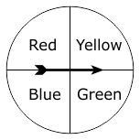  4. Use the spinner below to answer a-c.  a. What is the theoretical probability of landing on yellow?  b. Ana spins the spinner below 120 times. How many times is the spinner expected to land on yellow?  c. If Ana spins the spinner 30 times and lands on yellow 9 times, what was her experimental probability?  d. Was the experimental probability close to the theoretical probability? Explain why there may be discrepancy between the two.
Ticket out
1. In a game, the probability of winning is 1 out of 5. How many times could Lisa expect to win if she plays the game 85 times?

2. A bookshelf contains 6 fiction books, 2 non-fiction books, and 1 picture book. A book is chosen at random. What is the likelihood of choosing a fiction book?
A. impossible
B. not very likely
C. likely
D. certain

3. Evan has a bag of 8 red pencils, 12 green pencils, and 10 yellow pencils. If Evan randomly selects a pencil, what is the probability he will select a green pencil?

4. John rolled a number cube, labeled 1 through 6, 200 times and recorded each of his results. About how many times could John expect to roll a 2 or 3?

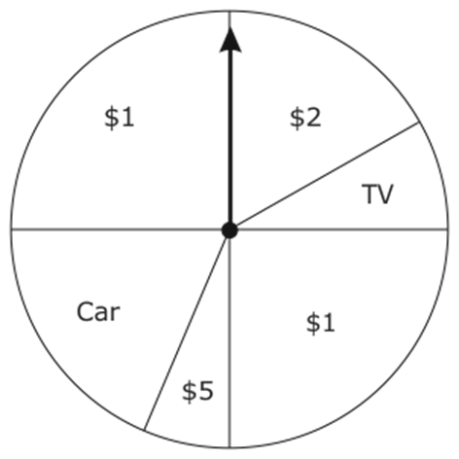

5. A prize wheel is spun one time to determine what prize a person will win. What is the likelihood a person will win a car?
A. impossible
B. unlikely
C. likely

6. Kaitlyn has 7 white chips, 5 red chips, and 8 blue chips in a bag.
• Without looking, Kaitlyn pulls a chip out, records the color, and puts it back in the bag.
• She does this 200 times.
About how many times could Kaitlyn expect to pull out a blue chip?
A. 25
B. 65
C. 80

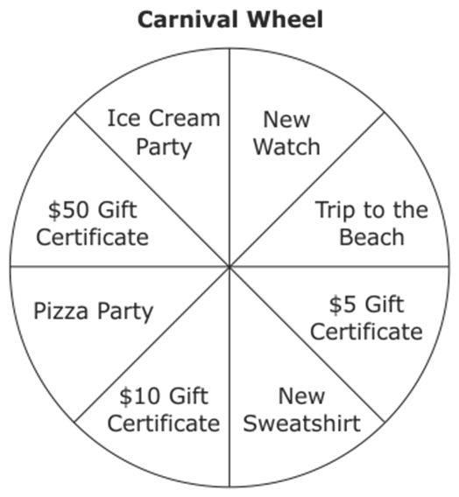
7. Jaden spins a wheel at the carnival to win a prize. What is the probability that Jaden will win a gift certificate?

