Name: Date:
7.RP EOG Review Block:
1. Each section of fence measures $5\frac{3}{4}$ feet. Each section is $\frac{1}{6}$ of the length of a side of the fence. How long is the side of the fence?
a. 18 feet b. 30 feet
c. $30\frac{3}{4}$ feet d. $34\frac{1}{2}$ feet

2. A cookie recipe requires $\frac{2}{3}$ cup of sugar for $\frac{1}{3}$ batch of cookies. How much sugar is needed for 1 batch of cookies?
a. $\frac{2}{9}$ cup b. 1 cup
c. $1\frac{1}{3}$ cups d. 2 cups

3. John is painting a box that is shaped like a cube. One-eighth of a bottle of paint covers $\frac{3}{4}$ of one face of the box. How many bottles of paint will John need to paint the entire box?
a. $\frac{1}{6}$ b. $\frac{9}{16}$
c. 1 d. 6

4. A painter used $\frac{3}{4}$ of a gallon of paint to cover $\frac{1}{4}$ of a wall. How many gallons of paint will the painter use for the entire wall?
a. $\frac{3}{16}$ b. $\frac{1}{2}$
c. 3 d. 4

5. Jerry ran $\frac{3}{4}$ of a mile in $\frac{3}{20}$ of an hour. What was Jerry’s rate of speed?
a. $\frac{9}{80}$ mph b. $\frac{9}{10}$mph
c. 3 mph d. 5 mph
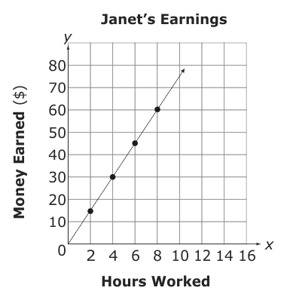
6. How much money does Janet earn per hour?
a. $7.50 b. $10.00
c. $10.50 d. $15.00

7. A car wash machine cleaned 20 cars in 50 minutes. At this rate, how many minutes will it take the machine to clean 1 car?
a. 0.4 b. 2.5
c. 3 d. 5

8. Belinda recorded the miles she drove and the number of gallons of gasoline she used in the table below. How many miles can Belinda drive on one gallon of gasoline?
Gallons of  Gasoline | Miles  Driven
8 | 172
10 | 215
14 | 301

a. 43.0 b. 32.5
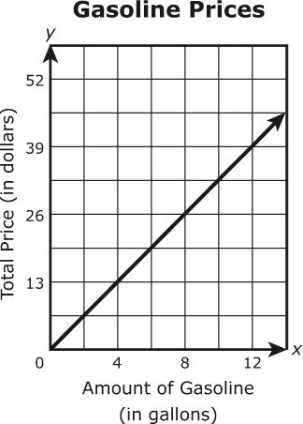
c. 21.5

9. The line graph shows the total price of different amounts of gasoline at a gas station for the same price per gallon. Based on the graph, what is the price of 1 gallon of gasoline?
a. $3.07 b. $3.10
c. $3.25 d. $4.00

Weight  (pounds) | Cost
3 | $8.37
6 | $16.74
9 | $25.11
10. The table below shows the cost of tomatoes, y, based on their weight, in pounds, x. Which equation would calculate the cost of x pounds of tomatoes?
a. $y=3x$ b. $y=2.79x$
c. $y=x+8.37$ d. $y=x+2.79$

Number of  Songs (n) | Cost (c)
5 | $7.50
7 | $10.50
13 | $19.50
11. The table shows the price of different numbers of downloaded songs. Which equation shows the cost, c, of n number of downloaded songs?
a. $c=0.67n$ b. $c=1.50n$
c. $c=2.00n$ d. $c=3.00n$

12. On a map of North Carolina, 27 centimeters represents 18 miles. Based on the map, which equation would calculate the number of miles between two cities, y, when they measure x centimeters apart?
a. $y=\frac{2}{3}x$ b. $y=\frac{3}{2}x$
c. $y=9x$ d. $y=18x$
x | y
–2 | –8
–1 | –4
0 | 0
1 | 4
2 | 8

13. Which equation shows the relationship between the x and y values in the table below?
a. $y=x+4$ b. $y=x-4$
c. $y=4x$ d. $y=-4x$

14. Mary bought a shirt on sale for $15.00. The sales tax was 10%. If Mary paid with a $20 bill, what was her change?
a. $1.50 b. $3.50
c. $4.90 d. $5.00

15. A shirt is on sale for $12.75. This is 15% off the original price. What was the original price of the shirt?
a. $13.00 b. $14.25
c. $14.50 d. $15.00

16. Darlene wants to buy a sweater that originally cost $32. It is on sale for 20% off. Sales tax is 6.75%. What is the final price of the sweater with tax?
a. $23.44 b. $23.87
c. $25.60 d. $27.33

17. The cost of a television was $500. The cost was increased by 10% and then decreased by 10%. What was the final price of the television?
a. $450 b. $495
c. $500

18. Taylor spent $107.96 at the grocery store, before sales tax. Sales tax on food is 2.5%. How much will Taylor pay in sales tax?
a. $2.16 b. $2.50
c. $2.70 d. $3.24

19. The Smith family went out to dinner. The price of the meal was $29.85. The sales tax was 6% of the price of the meal. The tip was 15% of the meal and the sales tax.How much money did the Smith family pay for the meal, including tax and tip?

a. $50.85 b. $36.39 c. $36.12 d. $31.95

