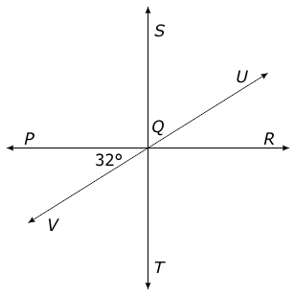
1. Using the figure to the right, name of pair of angles for each question below.
Vertical Angles: __________________________________
Complementary Angles: ___________________________
Adjacent Angles: _________________________________
Supplementary Angles: ____________________________

2. Two angles are supplementary. If one angle measures 72°, what is the measure of the other angle?

4. In the figure below, ∠GLH and ∠KLJ are vertical angles. Which is the measure of ∠GLK?
3. In the figure below, ∠GFH measures 96°.
What is the measure of ∠EFH?
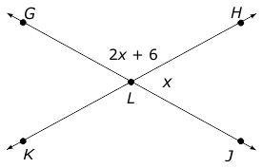
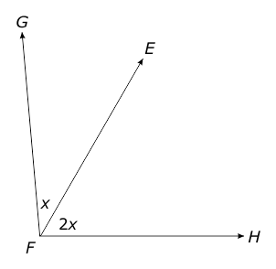

5. Complete the table below.
Angle | The Complement | The Supplement
17
43
72
105

1. Using the figure to the right, name of pair of angles for each question below.
Vertical Angles: __________________________________
Complementary Angles: ___________________________
Adjacent Angles: _________________________________
Supplementary Angles: ____________________________

2. Two angles are supplementary. If one angle measures 72°, what is the measure of the other angle?

4. In the figure below, ∠GLH and ∠KLJ are vertical angles. Which is the measure of ∠GLK?
3. In the figure below, ∠GFH measures 96°.
What is the measure of ∠EFH?

5. Complete the table below.
Angle | The Complement | The Supplement
17
43
72
105

