1. In the figure below, ∠OQP is a right angle.
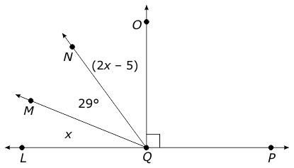
What is the measurement of ∠LQM?

2. In the figure below, ∠PQT measures (2x + 12)°.
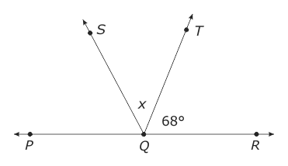
What is the measure of ∠PQS?
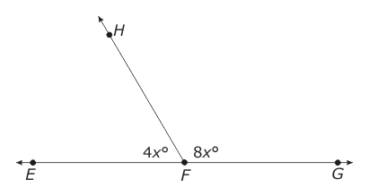
3. In the figure below, ∠EFH and ∠HFG are supplementary.

What is the measure of ∠HFG?

****4. Triangle JKL is an isosceles triangle. Side JL measures 8 inches and side KL measures 17 inches. What is the measure of the side JK?

****5. In triangle LMN, ∠L measures 40°, ∠M measures 60°, and ∠N measures 80°. Which lists the sides of the triangle in order from shortest length to longest length?

A.
B.
C.
D.
6. In the figure below, ∠LMR measures 120°.
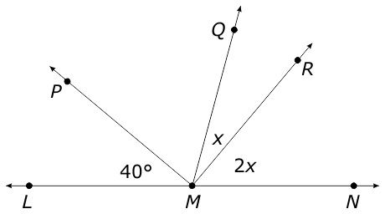

6. In triangle XYZ, side XY measures 6 inches, side YZ measures 8 inches, and side XZ measures 10 inches. Which lists the angles of the triangle in order from largest angle to smallest angle?

A. | ∠X, ∠Y, ∠Z

B. | ∠X, ∠Z, ∠Y

C. | ∠Y, ∠X, ∠Z

D. | ∠Z, ∠Y, ∠X

7. In the figure below, line JM is perpendicular to ray LP.
What is the measure of angle NLP?
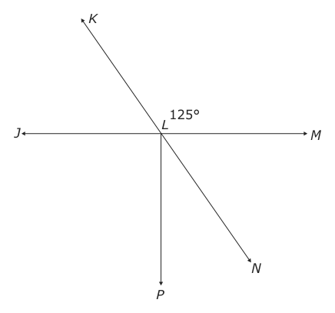
8. In the figure below, all lines intersect at point M. What is the measure of ∠GML?
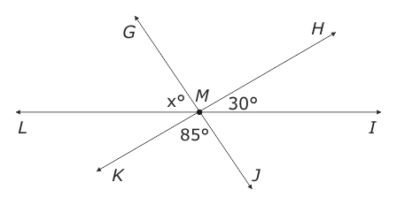
9. In the image below, ∠EFG is a right angle.
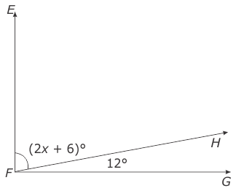 What is the value of x?
10. In the figure below, ∠PQR is 180°.
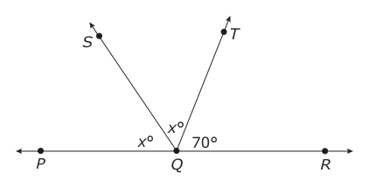 What is the measure of ∠SQT?

