Proportional:
Not Proportional:
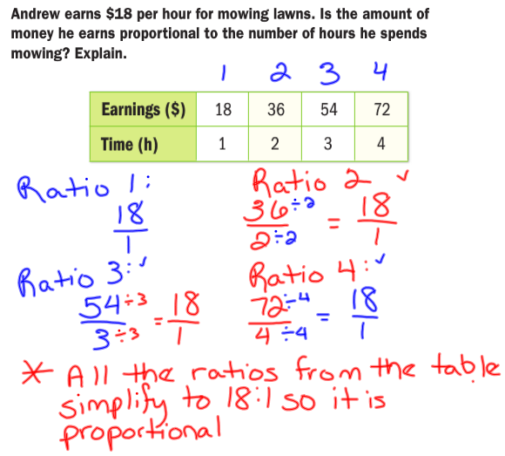

GRAPHING PROPORTIONAL RELATIONSHIPS

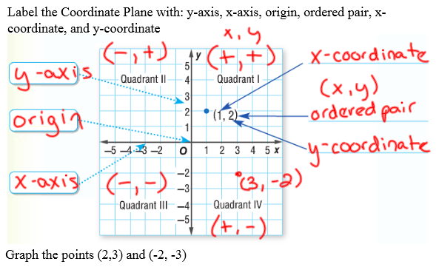

WE CAN TELL IF A RELATIONSHIP ON A GRAPH IS PROPORTIONAL IF IT IS:
1.

2.

