1. A scale drawing of a building is shown below. The scale of the drawing is 1 cm = 5 m.
NAME:_____________________________
DATE:______________________________
BLOCK:___________
DIRECTIONS: Cut and paste the correct answer next to the matching problem. Show your work on a separate sheet of paper. Make sure to label each problem on your paper.
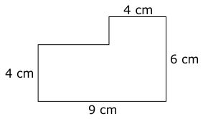 What is the perimeter of the actual building?

2. A scale drawing of a living room is shown below. The scale used to create this drawing is 1 in. = 2 ft.
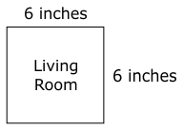
What is the area of the actual living room?

3. Natasha stands 5.5 feet tall and has a shadow that measures 3 feet long. At the same time, a tree next to Natasha has a shadow that measures 12 feet long. How tall is the tree?
4. Both bedrooms in the drawing below are square.
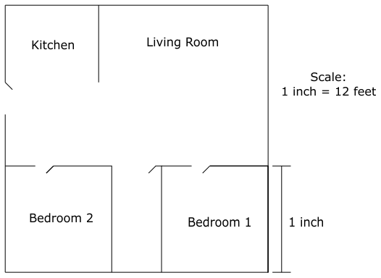
What is the area of Bedroom 1?
5. On a map, the scale is 1 inch = 15 miles. On the map, the distance between two cities is 10 inches. What is the actual distance between these cities?

6. Taylor made a scale drawing of his room using a scale of 0.25 inch = 1 foot. On the drawing, the length of his room is 3.25 inches and the width is 2.75 inches. What is the area of Taylor’s actual room?

7. On a scale drawing for a house, the dining room is 3 inches by inches.
- The scale for the drawing is inch = 2 feet.
- Flooring costs $2.75 per square foot.
How much will it cost to put new flooring in the dining room?
8. The actual distance between Mike’s house and John’s house is 28 km. On a map, the distance between the two houses is 3.5 cm. What is the scale used on this map?
A. 2 cm = 7 km B. 2 cm = 5 km
C. 1 km = 8 cm D. 1 cm = 8 km

9. Alex created a map of his neighborhood using a scale of 1 inch = 2 blocks. If his street is 6 blocks long, how long will it be on the map?
10. Peter drew a scale drawing of his room with a length of 10 inches. The actual length of his room is feet. The actual length of his desk is 40 inches. Approximately what is the length of the desk in the drawing?
11. Heidi used a scale of in. = 1 ft for a drawing of her bedroom. In her drawing, the bedroom measures in. by in. What is the area of Heidi’s actual bedroom?

150 mi | 150 m
3 inches | 2.5 inches
143 ${ft }^{2}$ | 1 cm = 8 km
144 ${ft}^{2}$ | 22 ft
144 ${ft}^{2}$ | 109.25 ${ft}^{2}$
$ 462.00 | 150 m
2.5 inches | 1 cm = 8 km
22 ft

