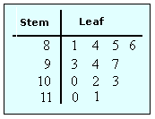
Stem and Leaf Plots NOTES

Key Terms

Stem-and-Leaf Plot: a plot where each data value is split into a "leaf" (usually the last digit) and a "stem" (the other digits). For example "32" would be split into "3" (stem) and "2" (leaf).

The "stem" values are listed down, and the "leaf" values go right (or left) from the stem values.
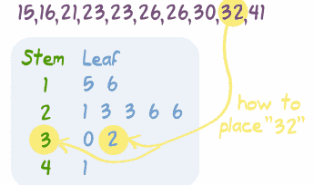

EX 1: Calculate the mean, median, and mode.
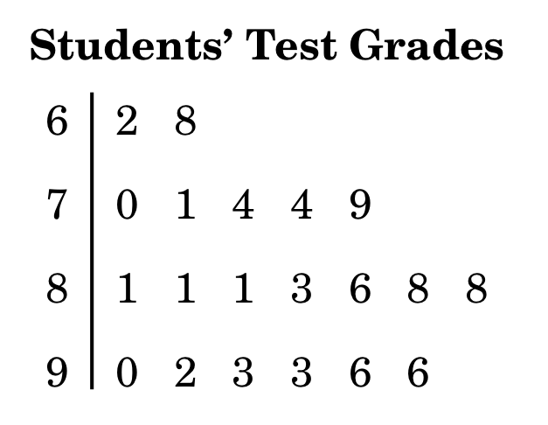MEAN: MEDIAN: MODE: ___________

EX 2: A team scored the following point totals in their last 7 basketball games.
65, 72, 53, 71, 60, 55, 68
Create a Stem and Leaf plot from the set of data and calculate the median.

- Calculate the mean median and mode from the following Stem and Leaf plot.

MEAN: MEDIAN: MODE: ___________

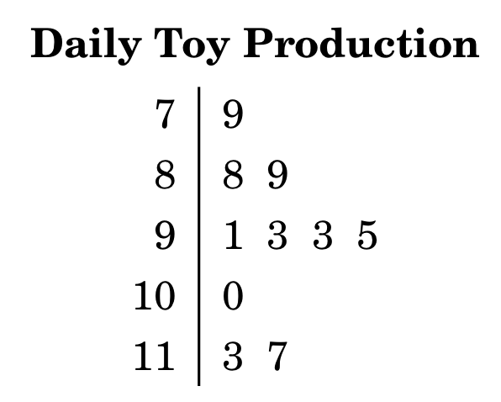

Practice

Wake Forest Math Students
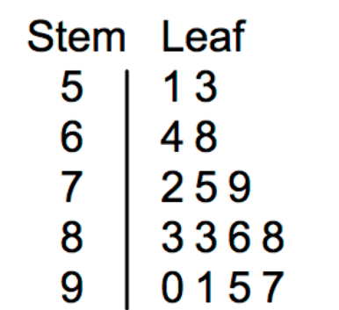

- What is the mean score of Wake Forest?

- What is the median score of Wake Forest?

- What is the mode of the Wake Forest scores?

- What is the range of the Wake Forest scores?

- What percent of the Wake Forest math students received an 80 or above?

- What would happen to the mean if you took out the 3 lowest Wake Forest scores?
Calculate the difference between the two means.
Ticket-Out-the Door

Boston College Math Students
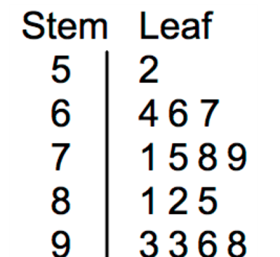

- What is the mean score of Boston College?

- What is the median score of Boston College?

- What is the mode of the Boston College scores?

- What is the range of the Boston College scores?

- What percent of the Boston College math students received an 80 or above?

- What would happen to the mean if you took out the 3 lowest Boston College scores?
Calculate the difference between the two means.

