1. In the first 15 minutes of a rainstorm, 0.4 inches of precipitation was recorded. If it continues to rain at the same rate, what will be the hourly rate of rainfall?

2. A road crew is installing 2 storm drains along every 1/8 mile of highway. What will be the number of storm drains along each 1-mile section of highway?

3. Penny walked 1/2 mile in 1/5 hour. Who of the following walked at the same rate as Penny?
a. Kamal: 3/4 mile in 2/5 hour
b. Jenna: 1 mile in 2/5 hour
c. Heather: 1/3 mile in 1/6 hour
d. Zander: 5/6 mile in 1/3 hour

4. Jeff has set a goal to drink 3/4 of a gallon of water per day. Which of the following correspond to Jeff’s rate?
a. 1/4 of a gallon in 1/3 of a day
b. 1/3 of a gallon in 1/4 of a day
c. 2/5 of a gallon in 3/10 of a day
d. 3/10 of a gallon in 2/5 of a day
e. 5/8 of a gallon in 5/6 of a day
f. 5/6 of a gallon in 5/8 of a day
1. In the first 15 minutes of a rainstorm, 0.4 inches of precipitation was recorded. If it continues to rain at the same rate, what will be the hourly rate of rainfall?

2. A road crew is installing 2 storm drains along every 1/8 mile of highway. What will be the number of storm drains along each 1-mile section of highway?

3. Penny walked 1/2 mile in 1/5 hour. Who of the following walked at the same rate as Penny?
a. Kamal: 3/4 mile in 2/5 hour
b. Jenna: 1 mile in 2/5 hour
c. Heather: 1/3 mile in 1/6 hour
d. Zander: 5/6 mile in 1/3 hour

4. Jeff has set a goal to drink 3/4 of a gallon of water per day. Which of the following correspond to Jeff’s rate?
a. 1/4 of a gallon in 1/3 of a day
b. 1/3 of a gallon in 1/4 of a day
c. 2/5 of a gallon in 3/10 of a day
d. 3/10 of a gallon in 2/5 of a day
e. 5/8 of a gallon in 5/6 of a day
f. 5/6 of a gallon in 5/8 of a day
5. A cookie recipe requires $\frac{2}{3}$ cup of sugar for $\frac{1}{3}$ batch of cookies. How much sugar is needed for 1 batch of cookies?

6. Jerry ran $\frac{3}{4}$ of a mile in $\frac{3}{20}$ of an hour. What was Jerry’s rate of speed?
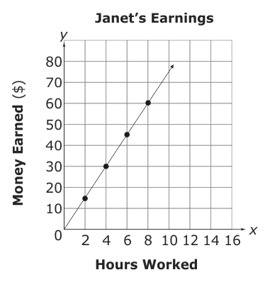

7. How much money does Janet earn per hour?

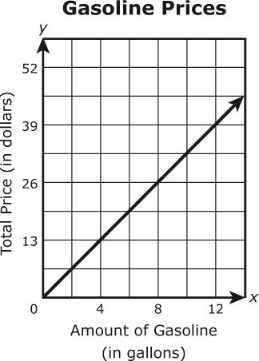

8. The line graph shows the total price of different amounts of gasoline at a gas station for the same price per gallon. Based on the graph, what is the price of 1 gallon of gasoline?

5. A cookie recipe requires $\frac{2}{3}$ cup of sugar for $\frac{1}{3}$ batch of cookies. How much sugar is needed for 1 batch of cookies?

6. Jerry ran $\frac{3}{4}$ of a mile in $\frac{3}{20}$ of an hour. What was Jerry’s rate of speed?

7. How much money does Janet earn per hour?

8. The line graph shows the total price of different amounts of gasoline at a gas station for the same price per gallon. Based on the graph, what is the price of 1 gallon of gasoline?

